**Content**

1. Nadpis 1 3

1. What is what

* Packer
* Ansible
* Kafka
* Sonar
* Prometheus
* OpenShift
* Selenium
* Cucumber
* TFS
* Pivotal
* Zabbix
* DBA

1. Nginx

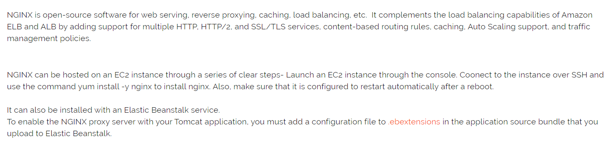

1. Database Administration
2. API Management tools
3. Configuration tools
   1. Ansible
4. Middleware

Postgres, Wireguard, Jboss, Wildfly Tomcat VMware